Extended Abstract for printed proceedings.

We present a finite-element (FE) approach to compute the stress-free shapes of non-rigid sheet metal parts, scanned in an over-constrained fixture setup. These fixture setups are commonly used for measuring non-rigid parts where one must compensate gravitational effects to comply with quality requirements. An over-constrained fixture setup induces part tensions, and one must understand how these affect a part’s geometry. Wrong interpretations can be made during quality inspection. This can lead to improper countermeasures, inappropriate tool modifications, or undesirable adjustments to manufacturing processes. Post-processing of measured part geometry supports the understanding of deflections caused by gravity or external fixture forces. We optically scan and digitize a part's geometry and use scan data to generate a mesh for a simulation. The simulation model considers material behavior and boundary conditions of the fixture. This digital twin is used to calculate the shape of the stress-free part , using an FE software package and performing iterative shape optimization. As the mesh is derived from an acquired point cloud, a CAD model is not needed in our workflow, assuming that the entire part can be scanned. Our approach is motivated by applications arising in the automotive and aerospace industries, where one must understand deformable behavior of thin sheet metal parts for quality assurance purposes. We demonstrate and discuss our approach for experimentally generated and simulated data for a simple experimental setup. We also present use-cases from the automotive industry. Our experimental results have maximal absolute error values less than 0.05mm, measured in surface normal direction. These values are on the same scale as measurement uncertainty for commonly used 3D scanning systems. These are the main contributions of this paper:

- Iterative shape optimization algorithm using FE simulation models
- Calculating the stress-free shape of measured parts by resolving deflections caused by gravity and over-constrained fixture setup
- Validation with experimental and simulation data demonstrating usability of our approach for real-world use-cases.

NAFEMS World Congress 2021 – Calculating Stress-free Shapes of Sheet Metal Parts Measured with Over-constrained Fixtures
Dipl.-Ing. F. Claus, Prof. Dr. H. Hagen
(Computergraphics & HCI, TU Kaiserslautern, Germany)
Prof. Dr. B. Hamann
(Department of Computer Science, University of California, Davis, CA 95616, U.S.A.)
Abstract
We present a finite element (FE) approach to compute the stress-free shape of a non-rigid sheet metal part. We employ optical scanning to digitize a part’s geometry, generating a point cloud that we mesh for FE computations applied to the part’s digital twin. We calculate the stress-free shape with a commercial FE simulation software package, also performing iterative shape optimization. As we assume that part geometry can be scanned entirely, a CAD model is not needed. Our approach is motivated by applications arising in the automotive and aerospace industries, where one must understand the deformable behavior of thin sheet metal parts for quality assurance purposes. We demonstrate the performance of our approach for experimentally generated and simulated data.

Introduction
In modern quality assurance processes, 3D scanning technology enables the inspection of big free-form surfaces in a short amount of time. Especially, in the automotive and aerospace industry, these kinds of measurement devices are used to assess the dimensional quality of produced sheet metal or sheet composite parts and assemblies i.e., car body parts or fuselage parts. By using 3D scanning, the whole visible surface of the pre-and post-assembly situation can be captured with a high density point cloud. These kinds of parts are usually considered to be non-rigid, thus they easily deform under their own weight - for definitions see (Abenhaim et al. 2011), (DIN EN ISO 2013).
When measuring non-rigid sheet materials, special requirements for fixture setups occur. In many applications, over-constrained fixture setups are used to compensate for deflections caused by gravity. Over decades different approaches are focusing on the multi-criterion optimization of locator points to improve the robustness of the measurement process while reducing the influence to the measurement results caused by the used fixture – for example see (Cai et al. 1996) (Liao and Wang 2008),(Lu and Zhao 2015), (Slon and Pandey 2020). Unfortunately, by using any kind of over-constraining fixture setup, the part inevitably gets tensioned and influenced in an unknown way. Finding an optimal fixture layout is influenced by different aspects like a part’s geometry or inspection features. This results in very time-consuming planning of the inspection strategy. Sometimes there are even multiple inspection strategies for the same part necessary to be able to inspect different aspects.
Due to the non-rigid behavior of sheet materials, not only the measurement process but also the post-assembly shape of such parts is highly sensitive and hard to control. Thus, the geometrical information obtained from a pre-assembly 3D scan can also be used for setting up a realistic Finite Element (FE) simulation model, often called digital twin. With these simulation models, precise predictions can be made - see (Cai et al. 2006), (Rezaei Aderiani et al. 2019). However, to achieve correct results, the obtained measurements need to be post-processed to eliminate deflections caused by the load case that was present during the measurement. These unwanted deflections are for example caused by gravity and fixture clamp forces.
To erase the need for multiple fixtures and costly planning processes, recent simulation-based approaches were developed that post-processes measurement data. This branch of methods is called “Fixtureless Inspection” or “Virtual Clamping” – see (Tuominen 2011), (Radvar-Esfahlan and Tahan 2012), (Thiébaut et al. 2017). The common idea of these kinds of approaches is to use an FE model based on CAD geometry and calculate the deflections caused by gravity using a non-over-constrained fixture setup. Then, the simulated displacement field is mapped to the measurement to correct the vertex positions of the acquired point cloud. From there on, a second simulation result can be mapped, putting the measured part virtually into any other fixture setup. The most challenging aspect is to solve the point cloud registration problem, especially when the part cannot be fully scanned. The underlying assumption for all approaches is that the actual part behaves similarly to the FE model. Also, mapping simulation results can only be applied to use-cases with non-over-constrained fixtures.
A second, more general kind of approach uses an inverse FE formulation to find the unloaded shape for a known loaded shape and corresponding load case. This branch of methods is called “Inverse Form Finding” or “Inverse FEM (iFEM).” An inverse formulation of the simulation problem enables a fast calculation of the unloaded shape. Inverse form finding can be applied to different kinds of problems like optimizing the initial blank shape for deep drawing processes (Parsa and Pournia 2007). A recursive approach for solving inverse form finding problems in isotropic elastoplasticity was presented in (Germain et al. 2014). The presented approach is very similar to the method that is used in this paper. Although iFEM methods are precise and fast, they all have in common that a special implementation for the solver is necessary.
To overcome the shortcomings of virtual clamping and iFEM, we developed an algorithm that does not need an inverse FE formulation (Claus et al. 2021). Also, the approach does not assume a similarity between CAD and measured parts like virtual clamping does. This is achieved by generating the simulation mesh directly from the measured geometry using available reverse engineering methods. The method can be implemented using commercial FE tools and provides reliable high precision results. In the paper (Claus et al. 2021) also a more detailed literature review and an extended problem description can be found. The so far presented method and validations are restricted to non-over-constrained measurement setups. Unfortunately, many real-world applications use over-constrained fixture setup.
We address this gap by modifying the recently proposed method to enable correct post-processing for measurements performed with over-constrained fixture setups. The contribution of this paper in particular are:
- Extension of the previously published method to enable correct post-processing for optical measurements performed on over-constrained fixtures
- Validations with simulation- and experimental data demonstrating the performance of the proposed method
The paper is organized as follows: Section 2 gives a brief repetition of the existing method, followed by the changes made for enabling the post-processing of over-constrained measurements. Section 3 demonstrates the performance of the proposed method by applying it to simulation and experimental data. Method and results are discussed in Section 4 followed by a conclusion in Section 5.

Method
As the method proposed here extends a method already published, this section is split into a brief review of the original method, followed by the changes that were implemented to extend the use of the existing method to measurements with over-constrained fixture setup.
Review of Earlier Method
Figure 1 gives an overview of the algorithm that is used to calculate the gravity-free-shape (GF-shape) based on a simulation model that preserves the measured geometry. The phrase GF-shape was introduced in (Claus et al. 2021) and describes the shape without the influence of gravity. For this paper, this wording is vague, as not only gravity is considered for the compensation algorithm. Nevertheless, to use consistent wording across all figures and references we also call the stress-free shape GF-shape as well. Figure 1 includes Input, Output, and two serial calculation loops. All four components are discussed in the following. As an input, a simulation model of the measured part must be derived. Different methods can be used to convert the acquired point cloud to a simulation mesh. (Gentilini and Shimada 2011), for instance, used bubble packing (Shimada 1993) to reduce the density of a measured point cloud. After triangulating this coarsened point cloud, FE shell elements are defined on the triangulated mesh to run simulations. More recently, (Liu et al. 2017) published a method that automatically creates volume FE meshes from STL files. A manual way for generating an FE mesh from a measurement is to use commercially available software tools for reverse engineering. The measured point cloud is reconstructed by parametric surfaces which can be considered as a CAD representation of the measured object. This CAD representation can be meshed. Due to available methods for generating FE meshes from point clouds we consider the meshing as a problem that is already solved. Geometry, material model, interplay between components, interactions with the fixture, and direction of gravitational force are considered in the complete simulation model.
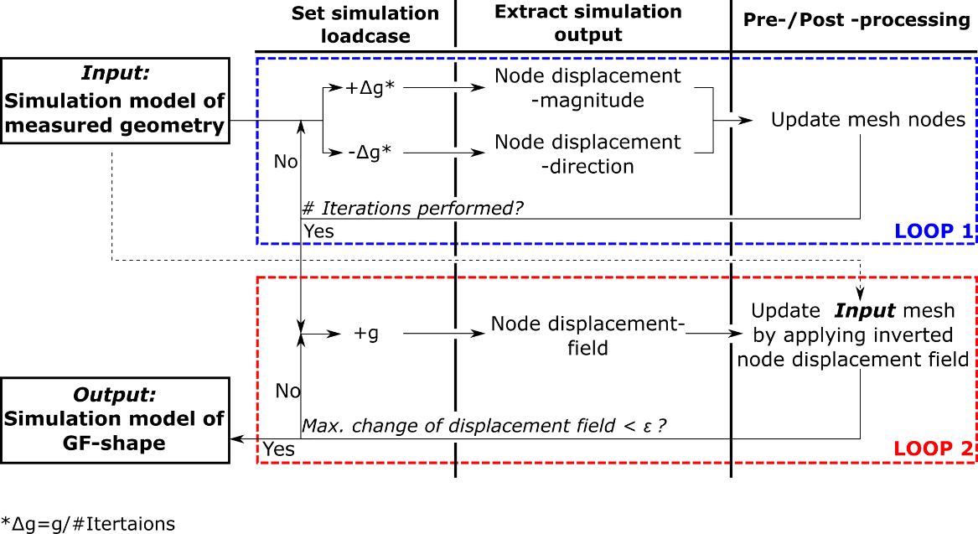
Figure 1: This figure from (Claus et al. 2021) provides an overview of the proposed algorithm. (Published under Creative Commons Attribution 4.0 International License ; see https://creativecommons.org/licenses/by/4.0/ , changes: spelling was revised)
The algorithm, see Figure 1, consists of two sequential iterative loops. The first iteration “Loop 1” results in a first coarse approximation of the GF-shape. This is achieved by iterative unloading. This unloading is achieved by dividing the load magnitude of the gravity by a fixed number of iterations. In each iteration, two simulations are performed, one applying the partial load in the positive and one in the negative direction of gravity. From the first simulation result, the node displacement magnitude is extracted; from the second result, the direction of displacement is obtained for the following node update. As “Loop 1” does not consider non-linear effects, a second loop is necessary to correct the errors that remain after the first loop. The output of “Loop 1” serves as input for “Loop 2”. This second loop runs a forward simulation and applies the resulting displacement field in inverse direction to the original measured shape resulting in a shape that is closer to the desired GF-shape. This loop terminates when maximum corrections become smaller than a user-defined threshold value ε. The mathematical details and an extended description of the algorithm can be found in (Claus et al. 2021).
Extensions to the Earlier Method
To apply the proposed algorithm to measurement data acquired on over-constrained fixture setups, different changes are made. Figure 2 shows an overview of the changes made to the existing algorithm. It is most important to add the support forces to the input-simulation model. By adding this(these) force(s), the information necessary for resolving the over-constrained situation is provided to the model. Not all support boundaries need to be substituted by forces in the simulation model, only the supports that cause the over-constrained situation must be considered for change. Only for the supports that over-constrain the part, the forces occurring during measurement must be obtained. The second modification to the original method is to skip the first loop of the algorithm. This loop is intended to provide a robust way of finding a first coarse approximation of the GF-shape. “Loop 2” improves the result of “Loop 1” resulting in a better approximation of the GF-Shape. “Loop 1” is now intentionally skipped as we assume that the part is already in a shape similar to the GF-Shape due to the over-constrained fixture. Although skipping “Loop 1” is optional, the computational cost can be reduced drastically as this loop is the most expensive part of the overall algorithm.
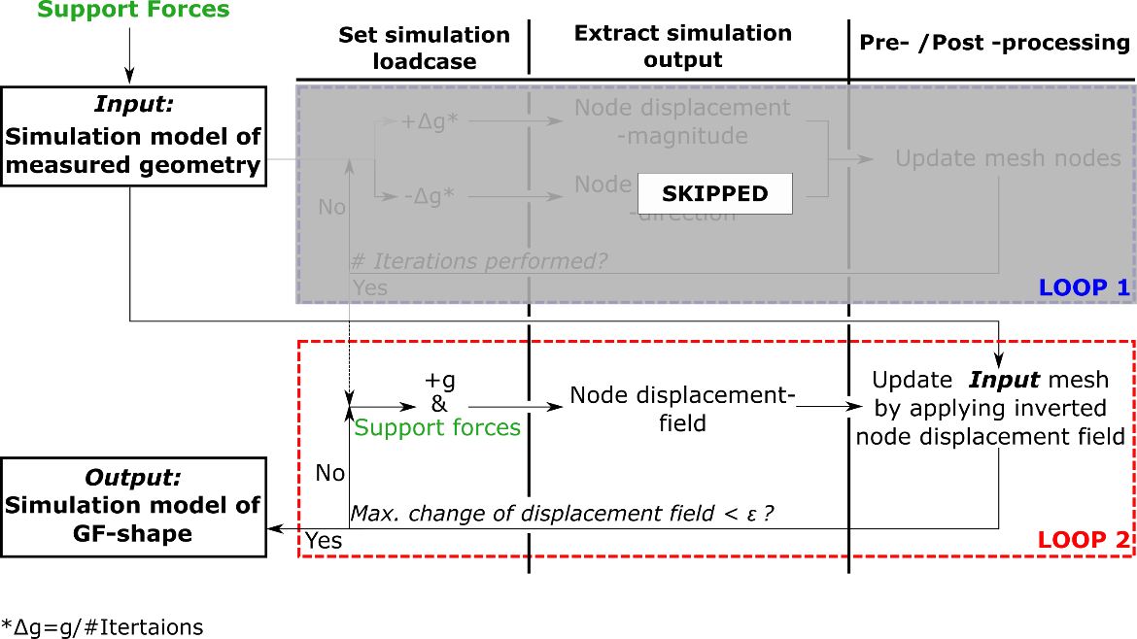
Figure 2: Modifications made to the original method: (1) Adding specific support forces, (2) skipping "Loop 1".
In the second loop, the support forces are considered for the load case. All loads – gravity and support forces – are applied in one simulation step. This loop performs iteratively a simple forward simulation and applies the resulting node displacements in inverse direction always to the original input simulation model. The resulting shape converges towards the desired GF-shape. The change of the displacement output is monitored and serves as adaptive termination criterion for this loop. This method does only need access to the node positions of the simulation model and the displacement output of the simulation result. It can be easily implemented with almost any commercial FE simulation software.

Case Study
To validate the assumption that a part geometry measured with an over-constrained fixture setup can be post-processed using the method presented in Figure 2, two experiments were accomplished. First, simulation data of a real-world example are used for validation, second, experimental data are used for validation, showing the performance of the method as well as pitfalls when working with real measurement data.
Validation with Simulation Data
First, we investigate whether the calculation of the GF-shape based on an over-constrained boundary situation is possible in theory. For two different parts, the deflections caused by gravity when applying a hypothetical fixture setup are simulated.
Based on the resulting geometry and forces, obtained from the simulation results, the GF-shape is calculated with the proposed method. The GF-shape is validated by comparing it to the initial shape which serves as ground truth. Figure 3 is showing these results. The geometry in the first row is a simple plane sheet metal (steel) with the dimensions 200mm x 300mm x 0.7mm. As initial shape, CAD (ideal plane) is chosen. The second picture of the upper row shows the boundary conditions and the resulting deflections caused by gravity. In this example, the Z-boundaries are not ideal in-plane or symmetrical. This was done on purpose to prevent a "lucky strike" when calculating the GF-shape. The shape on the fixture serves as input for the calculation of the GF-shape. To resolve the over-constrained situation, F_{Z4} is added to the simulation model. The third picture of the upper row shows the calculated GF-shape compared to the initial shape. No relevant differences can be observed.
The second example shows an engine hood from a BMW E46. In this example, the initial shape (GF-shape) is considered to be imperfect showing deviations up to 13.5mm compared to CAD. However, the fixture design this time is derived from CAD and all Z-supports match with CAD-position. The second picture of the second row shows a comparison between the CAD and the shape that results when applying the fixture boundaries and gravity to the initial shape. This comparison would be typically made in real-world applications, but obfuscates the underlying shape of the part. Based on the shape shown in the second picture, again, the GF-shape is calculated by considering F_{Z4}. This part weighs about 18kg, so round about half of the weight (89N ≈ 8.9kg) is supported by Z₄.
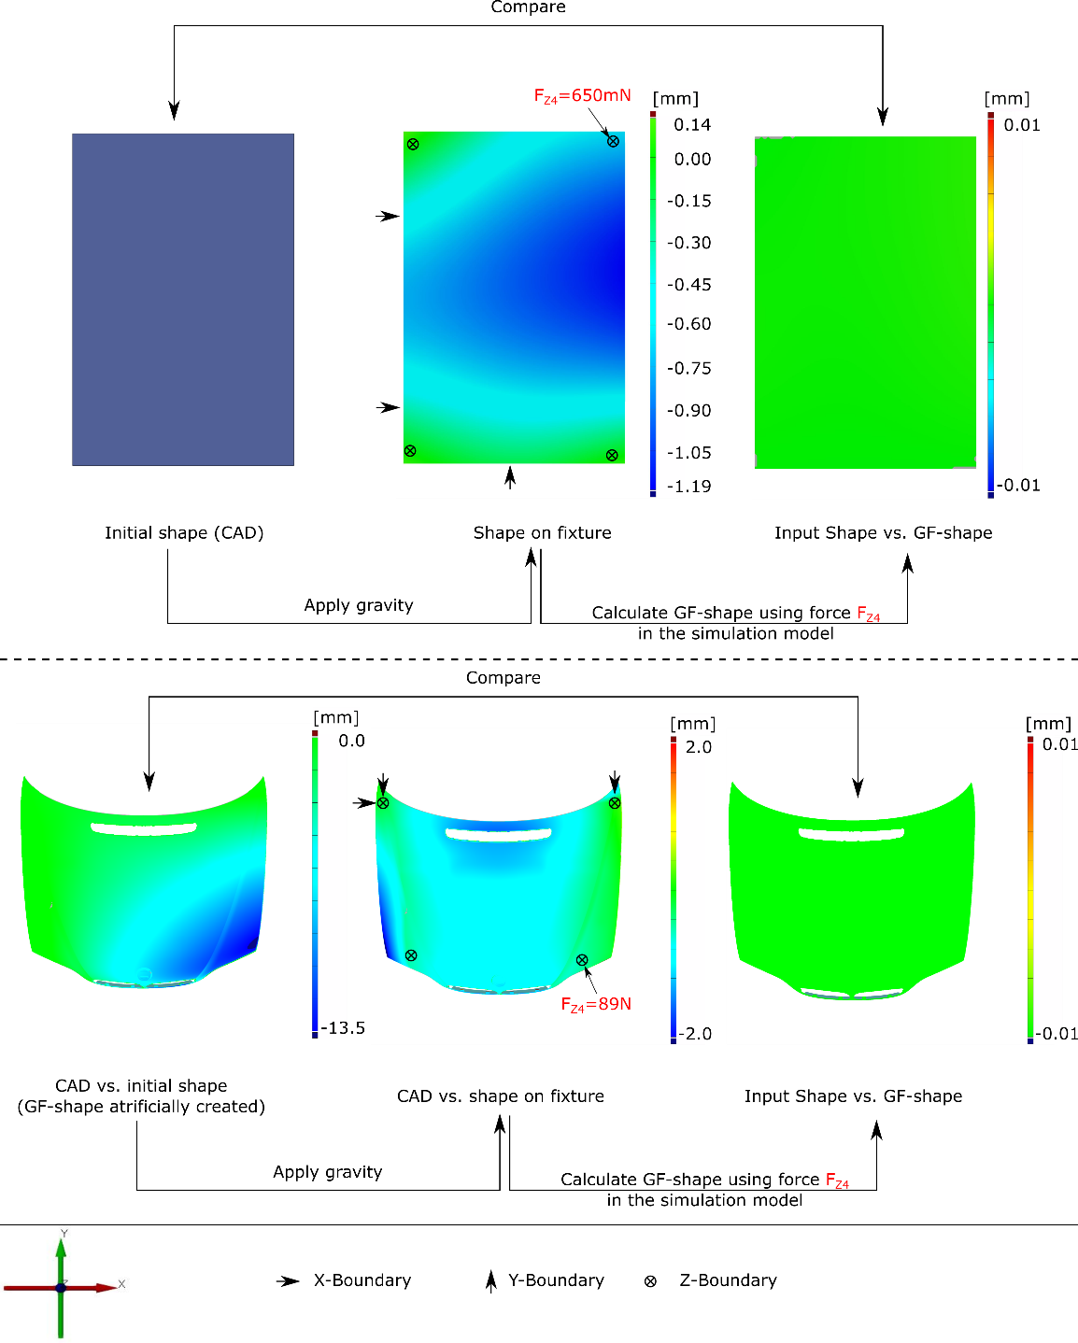 Figure 3: Results of validation with simulation data. Top row: simple plane sheet metal,(from left to right): CAD geometry, deformations occur on fixture, calculated GF-shape compared to input shape. Bottom row: engine hood of BMW E46 with shape deviations (steps analogous to first row).
This is plausible because of the shape deviation on the initial shape. Although this uneven weight distribution is generally undesired it is induced on purpose for demonstrating the robustness of the method. The resulting GF-Shape is again compared to the initial shape and also for this part, no relevant differences can be measured.
Validation with Experimental Data
Experimental Setup
To ensure, that the promising results from the validations with simulation data are also valid when working with real measurements, an experiment similar to the validations published in (Claus et al. 2021) was performed. The experimental setup is depicted in Figure 4. The used optical measurement device is a structured light scanner from HP (HP Pro S3). To measure the force acting on the over-constraining support, a precision scale is used. The basic idea of this experiment is to calculate the GF-shape based on two different fixture setups – over-constrained and not over-constrained. The assumption is, that calculating the GF-shape based on a measurement performed with a non-over-constrained fixture setup is valid and can be used as a reference. As there is only one GF-shape for a specific part, the results of both calculations can be compared.
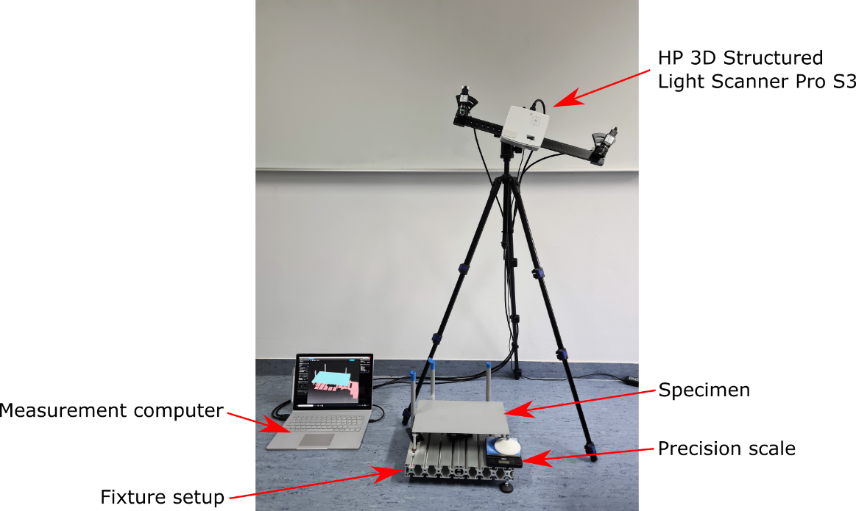
Figure 4: Experimental setup. All used components for validation are depicted.
Execution of Experiment
The workflow of the validation is depicted in Figure 5. The used part is the same already used for the previous publication and also for the virtual validations (Figure 3). As only one GF-shape exists, a valid calculation of the GF-shape based on any kind of fixture should result in the same shape. In the depicted workflow, the same part is measured on two fixture setups – over-constrained and non-over-constrained. The over-constrained fixture setup is extended by a force sensor to capture the weight that acts onto the fourth support to be able to resolve the over-constrained situation. Based on the two measurements, for each acquired point cloud, a simulation model is derived.
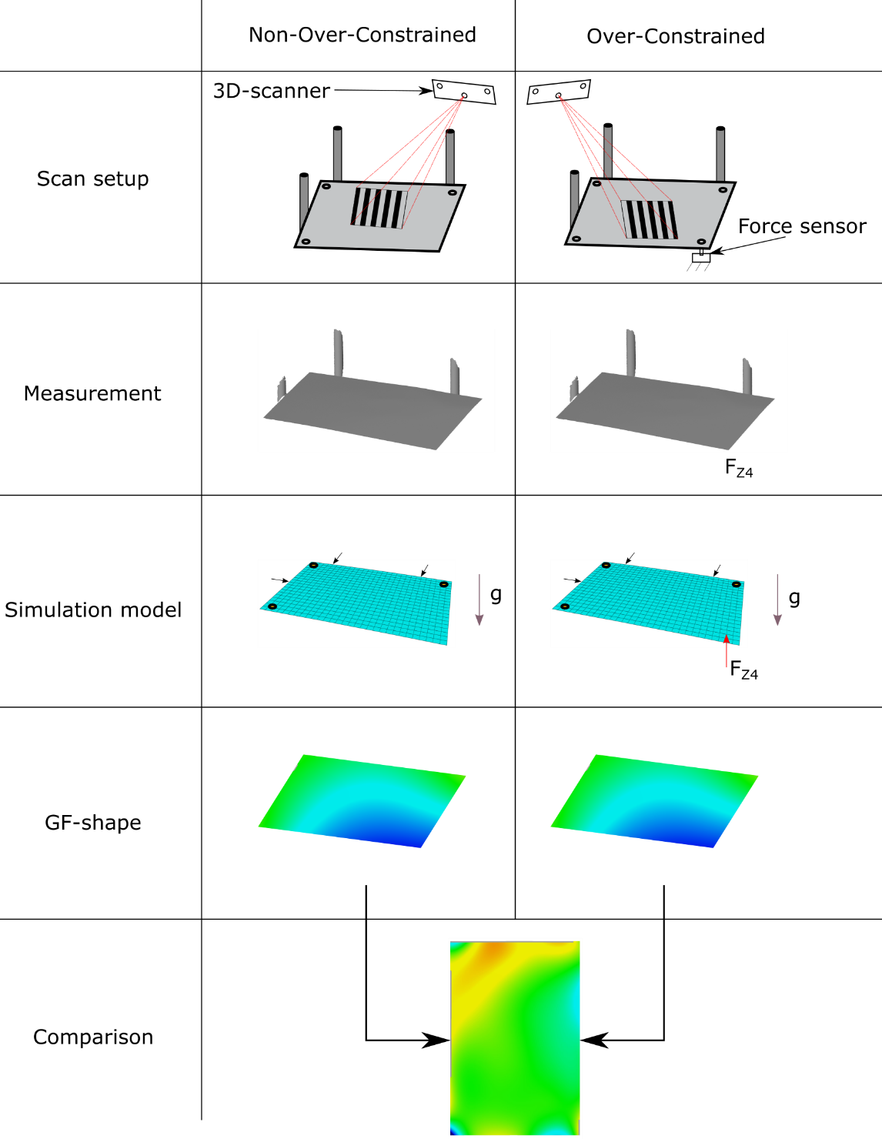 Figure 5: Validation workflow for experimental data. The left column shows the validation steps with non-overconstrained fixtures; the right column shows the analogous validation with over-constrained fixtures.
We used 15000 first-order shell elements to mesh the measured surface. The reason for choosing that many mesh elements is to ensure that no effects due to low mesh resolution affect the simulation results in a relevant way. Locator positions are modeled as displacement boundary and the material model is assumed to be linear elastic isotropic steel (Young's Modulus: 210 GPA, Poisson's Rate: 0.3, density: 7.85 g/cm³). For the over-constrained setup, the measured support force is modelled as concentrated force. Next, both GF-shapes are calculated and a direct comparison between the results is made. The results and further improvement to the simulation model are presented in the following.
Results and Error Detection
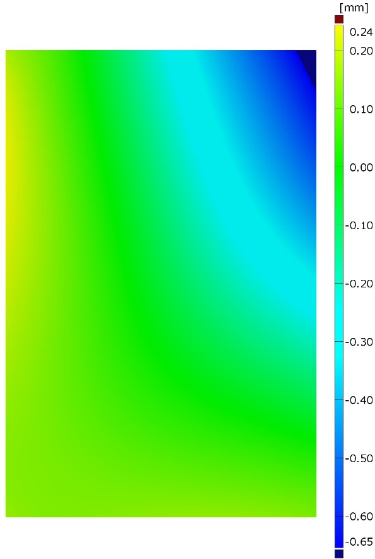
Figure 6: First validation attempt with experimental data. Errors up to 0.65mm are observed.
First Attempt - The result of the first attempt to perform the validation with experimental data is shown in Figure 6. The colored field shows the distance between the results of two compensation calculations that were performed as described in Figure 5. Deviations up to 0.65mm can be observed which is bad compared to the validations performed with simulation data, see Figure 3. To understand the occurring errors, different tests were performed.
Reproducibility of Experimental Setup - To ensure that the measurement results that are acquired with the current experimental setup are reproducible, a series of measurements were performed. Between measurements, the specimen was taken off the fixture and re-positioned again on the same fixture. Only the specimen is moved, the fixture and scan setup remain at the same position untouched. The evaluation of the measurement series shows no deviations above measurement noise, thus we can say that the fixture setup does fulfill the requirements to perform the intended validation.
Thickness Distribution - To investigate the impact of varying thickness throughout the specimen surface, we measured the thickness of the specimen at multiple points (20) evenly spaced. Therefore, a precision gauge was used. We could not observe differences above 0.01mm. We consider effects of varying thickness as negligible.
Weight of Specimen - To ensure that the physical properties of the simulation model match with the properties of our specimen, we compared the weight of the specimen to the simulation model. The specimen weighs 353.8g, the simulation software estimates a weight of 353g for the virtual part. The difference of 0.8g is negligible and does not explain the occurring differences.
Chosen FE Elements - The impact of the selected FE elements on the simulation result was tested by trying different, higher-order shell and volume elements. No recognizable impact was found when using elements that provide a higher precision at a higher computational cost.
Stiffness of Specimen - As the simulation model of the specimen already considers correctly (verified): density, thickness, locator position, the direction of gravity, geometrical properties, well-chosen FE Elements, and Solver, we investigated the last possible variable in the FE model - the material model. An experiment was performed to verify the measured forces for different Z-positions (height) of Z₄.
Figure 7: Comparison of measured force-displacement curve at support with force sensor and a simulated curve. Both curves show the same linear behavior but with different pitches.
An analog simulation series was performed and the results are compared to the experiment. In Figure 7 both force-displacement curves – simulated and experimental - are plotted. The relation between Z-position and measured force was found to be linear. The experimental data is showing a similar behavior compared to the simulation results. However, the pitch of both curves is different. As the pitch of the shown force-displacement curve is related to the stiffens of the part we identify the material model as a relevant source of error. Literature research underpins this assumption. In (Kizu et al. 2015) and (Banabic 2000) the anisotropy of sheet metals is investigated/described. Due to the manufacturing process of sheet metals (mostly cold rolled), Young's Modulus is dependent on the rolling direction. Thus, the material model for the general case must be assumed to be orthotropic.
$$\left\{\begin{matrix}ε_{1} \\ ε_{2} \\ γ_{1}\end{matrix}\right\}=\left[\begin{matrix}\frac{1}{E_{1}} & \frac{{-υ}_{12}}{E_{1}} & 0 \\ \frac{{-υ}_{12}}{E_{1}} & \frac{1}{E_{2}} & 0 \\ 0 & 0 & \frac{1}{G_{12}}\end{matrix}\right]\left\{\begin{matrix}σ_{11} \\ σ_{22} \\ τ_{12}\end{matrix}\right\}$$
Equation 1
To deal with the different stiffnesses observed between the physical part and simulation model, the material model for the simulation is changed from a linear elastic isotropic to an orthotropic material model commonly used for thin parts (shells). The material parameters that must be defined for the in-plane stress-strain relations are: E₁, E₂, υ₁₂, G₁₂, see Equation 1. In ABAQUS also the shear moduli G₁₃ and G₂₃ can be defined as they might be necessary to model transverse shear deformation in a shell. To define all unknown parameter states only a few non-destructive methods are available. One possible system is the product Resonalyser® (BYTEC BV). Due to the lack of measurement devices, we went with a parameter study. In this study, 2000 simulations were performed equally distributed in the parameter space using Latin-Hypercube sampling. The chosen parameter ranges, in particular, are listed in Table 1Error! Reference source not found..
Table 1: Material parameters. The table shows the varied parameter with selected ranges and the set of parameters that matches experimental data optimally.
Material Parameter | Tested Range | Best Match
E₁ | 189-245 GPA | 211 GPA
E₂ | 189-245 GPA | 215 GPA
υ₁₂ | 0.1-0.4 | 0.29
G₁₂ | 72-100 GPA | 93 GPA
G₁₃ | 72-100 GPA | 95 GPA
G₂₃ | 72-100 GPA | 93 GPA
The stiffness of all 2000 simulation models is evaluated by simulating the force-displacement curve of the support Z₄ for each model. Afterward, the pitch of each curve is calculated and compared to the physically measured results. The material parameters for the simulation model that matches best with the measurements are also listed in Table 1Error! Reference source not found..
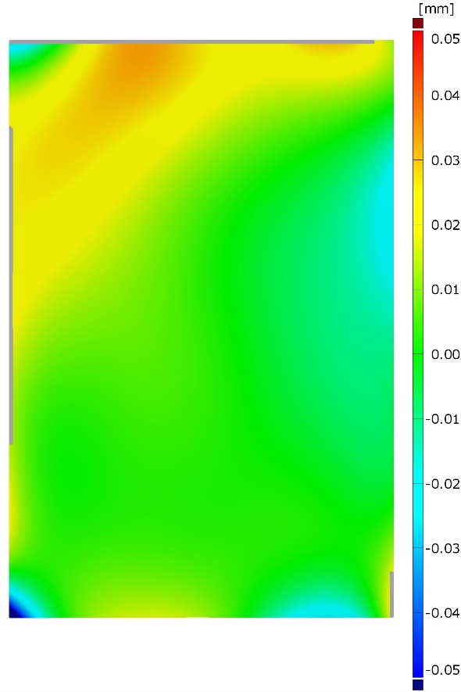
Figure 8: Validation with experimental data but with a changed material model (orthotropic). Maximum errors are mostly below 0.05mm
Final Results -When applying this best matching set of material parameters to the simulation model and redo the validation, the error was reduced significantly. In Figure 8 this result is shown. The maximum observed error is -0.07mm for a single spot (lower-left corner), but for most of the part, the error is below +/-0.05mm. The average error across all mesh nodes is +/-0.01mm.
Runtimes
To compare the proposed algorithm in terms of computational times, execution times for the validations with experimental data were measured. Especially, the time savings compared to the original method are highlighted. Table 2Error! Reference source not found. is showing the achieved runtimes. It can be observed that the time savings are mainly reasoned by the reduced number of iterations needed. This is plausible, as for the calculation of the GF-shape based on over-constrained measurements, “Loop 1” of the algorithm can be skipped, see Section 2. The total execution time is affected by the number of iterations and solver time per iteration and includes pre-and post-processing steps like reading displacements from previous iteration results and updating node positions.
All execution times were obtained with the following software/hardware:
- Processor: Intel i7-5820k@3.6GHz
- Memory: 64Gb DRR4@2100MHz
- Storage: M.2 SSD read;write 3200MB/s;1400MB/s
- GPU: Not used for simulation
- OS: Microsoft Windows 10 Pro
- Solver: Abaqus 2019 (Dassault Systèmes)
Table 2: Execution times for calculating GF-shape for the two load cases, depicted in Figure 5.
Task | Solver Time per Iteration | Number of Iterations | Total Execution Time
Over-Constrained | 20s | 5 | 320s
Non-Over-Constrained | 20s | 10 | 530s

Discussion
In summary, the validations with simulation data are showing the correctness of the modified gravity compensation method. However, the validations with the experimental data are also showing the challenges that occur when applying the method to real-world problems. Due to the force-controlled manner of the approach, the calculation of the GF-shape is sensitive to the stiffness properties of the simulation model. In the demonstration use-case - the plane sheet metal - the stiffness of the part is directly related to the material properties. For more complex parts, the stiffness might be mainly driven by geometrical properties but this statement needs to be validated for each case individually. The simulation model used for calculating the GF-shape must be validated and well known. If the simulation model was validated carefully, the presented method can be used for reliably calculating the GF-shape. This statement is underlined by the validations with simulation data. These validations show extremely small errors, way below +/-0.01mm between known and calculated GF-shape. This precision can be expected if the simulation model is accurate. Unfortunately, many aspects must be considered and validated during the generation of the simulation model (digital twin) which might result in time-consuming preparations. However, a precise simulation model, reflecting the real part behavior is crucial for any kind of FE based post-processing method. Thus, we can argue that in terms of precision the method proposed in this paper is still preferable compared to mapping methods like presented in (Thiébaut et al. 2017), as no further assumptions are made. For applications where real-time support is implied, mapping methods still are advanced due to faster run-times and the unrequired derivation of a simulation model for each measurement.
A second aspect that is revealed by the validations with experimental data, is that the way the original method from (Claus et al. 2021) was validated is not entirely correct and does not hold for the general case. As the same part was used but the material properties were assumed to be linear-elastic and isotropic, the calculated GF-shape based on the non-over-constrained measurement is not correct. However, the validation showed minimal errors which resulted in the wrong interpretation. Thus, the way to validate the calculation of the GF-shape proposed in the present work is preferable. Unfortunately, also the experimental validation presented in this paper is not watertight. Especially, the parameter study that was performed to identify the unknown orthotropic material parameters is vague. Many different, not similar material parameters can be used to achieve the desired stiffness. The comparison of Figure 8 is mainly affected by the resulting stiffness and setting the individual parameter realistically is not necessary to achieve good results. Although the chosen way of finding suitable material parameters might be not ideal, we argue that all found parameter sets that result in the same linear behavior shown in Figure 7 could serve for performing the shown validation. To improve precision, one could estimate material parameter values by considering a part’s manufacturing process or using non-destructive testing. Due to the simple load case and the observed linear force-displacement curve, no non-linearity caused by the material need to be taken into account. Smaller differences might be explained by an incorrect material model, but the observed differences are already mostly below the uncertainty of the used measurement machine.

Conclusion
We presented an FE based approach to calculate the GF-shape based on a point cloud that was acquired with an over-constrained fixture setup. The proposed method is a modified version of our previously published approach which was restricted to non-over-constrained fixtures. The approach was implemented using commercially available simulation software. As input serves a simulation model that is derived from the measurement. By that, geometrical effects are taken into account. No CAD model is needed implied the part can be fully scanned. We demonstrated the precision of our method by performing validations with experimental and simulation data. The achieved validation results show errors of up to +/- 0.05mm measured in surface normal direction. As these errors are below the measurement uncertainty of commonly used 3D scanner, the use for real applications is underpinned.
Further research could investigate the convergence behavior of the algorithm in order to further reduce the number of needed iterations.

Acknowledgments
This research was funded by the Deutsche Forschungsgemeinschaft (DFG, German Research Foundation) – 252408385 – IRTG 2057. We thank Q-DAS GmbH for providing CAD models.

Publication bibliography
Abenhaim, Gad N.; Tahan, Antoine S.; Desrochers, Alain; Maranzana, Roland (2011): A Novel Approach for the Inspection of Flexible Parts Without the Use of Special Fixtures. In Journal of Manufacturing Science and Engineering 133 (1), p. 11009. DOI: 10.1115/1.4003335.
Banabic, D. (2000): Anisotropy of Sheet Metal. In Dorel Banabic, H.-J Bunge, K. Pöhlandt, A. E. Tekkaya (Eds.): Formability of Metallic Materials, vol. 42. Berlin, Heidelberg: Springer Berlin Heidelberg (Engineering Materials), pp. 119–172.
BYTEC BV: Resonalyser®. Available online at http://resonalyser.com/, checked on 5/25/2021.
Cai, W.; Hu, S. J.; Yuan, J. X. (1996): Deformable Sheet Metal Fixturing: Principles, Algorithms, and Simulations. In Journal of Manufacturing Science and Engineering 118 (3), pp. 318–324. DOI: 10.1115/1.2831031.
Cai, Wayne W.; Hsieh, Ching-Chieh; Long, Yufeng; Marin, Samuel P.; Oh, Kong P. (2006): Digital Panel Assembly Methodologies and Applications for Compliant Sheet Components. In Journal of Manufacturing Science and Engineering 128 (1), pp. 270–279. DOI: 10.1115/1.2112967.
Claus, Felix; Hagen, Hans; Hamann, Bernd (2021): Calculating the gravity-free shape of sheet metal parts. In Int J Adv Manuf Technol 113 (11-12), pp. 3401–3417. DOI: 10.1007/s00170-021-06702-6.
DIN EN ISO (2013): DIN EN ISO 10579:2013-11, Geometrische Produktspezifikation (GPS)_- Bemaßung und Tolerierung_- Nicht-formstabile Teile (ISO_10579:2010, einschließlich Cor 1:2011); Deutsche Fassung EN_ISO_10579:2013. Berlin: Beuth Verlag GmbH.
Gentilini, Iacopo; Shimada, Kenji (2011): Predicting and evaluating the post-assembly shape of thin-walled components via 3D laser digitization and FEA simulation of the assembly process. In Computer-Aided Design 43 (3), pp. 316–328. DOI: 10.1016/j.cad.2010.11.004.
Germain, Sandrine; Landkammer, Philipp; Steinmann, Paul (2014): On a recursive formulation for solving inverse form finding problems in isotropic elastoplasticity. In Advanced Modeling and Simulation in Engineering Sciences 1 (1), p. 10. DOI: 10.1186/2213-7467-1-10.
Kizu, Taro; Okuda, Kaneharu; Nagataki, Yasunobu; Urabe, Toshiaki; Seto, Kazuhiro (2015): Influence of Tensile Strain on Young’s Modulus in High-strength Cold-rolled Steel Sheets. In ISIJ International 55 (7), pp. 1502–1511. DOI: 10.2355/isijinternational.55.1502.
Liao, Xiaoyun; Wang, G. Gary (2008): Simultaneous optimization of fixture and joint positions for non-rigid sheet metal assembly. In The International Journal of Advanced Manufacturing Technology 36 (3-4), pp. 386–394. DOI: 10.1007/s00170-006-0827-5.
Liu, Yan; Saputra, Albert A.; Wang, Junchao; Tin-Loi, Francis; Song, Chongmin (2017): Automatic polyhedral mesh generation and scaled boundary finite element analysis of STL models. In Computer Methods in Applied Mechanics and Engineering 313, pp. 106–132. DOI: 10.1016/j.cma.2016.09.038.
Lu, Cong; Zhao, Hong-Wang (2015): Fixture layout optimization for deformable sheet metal workpiece. In The International Journal of Advanced Manufacturing Technology 78 (1-4), pp. 85–98. DOI: 10.1007/s00170-014-6647-0.
Parsa, Mohammad Habibi; Pournia, Payam (2007): Optimization of initial blank shape predicted based on inverse finite element method. In Finite Elements in Analysis and Design 43 (3), pp. 218–233. DOI: 10.1016/j.finel.2006.09.005.
Radvar-Esfahlan, Hassan; Tahan, Souheil-Antoine (2012): Nonrigid geometric metrology using generalized numerical inspection fixtures. In Precision Engineering 36 (1), pp. 1–9. DOI: 10.1016/j.precisioneng.2011.07.002.
Rezaei Aderiani, Abolfazl; Wärmefjord, Kristina; Söderberg, Rikard; Lindkvist, Lars (2019): Individualizing Locator Adjustments of Assembly Fixtures Using a Digital Twin. In Journal of Computing and Information Science in Engineering 19 (4), p. 3. DOI: 10.1115/1.4043529.
Shimada, Kenji (1993): Physically-based mesh generation: automated triangulation of surfaces and volumes via bubble packing. Massachusetts Institute of Technology.
Slon, Christopher; Pandey, Vijitashwa (2020): An Optimization Framework for Fixture Layout Design for Nonrigid Parts: An Automotive Perspective. In SAE Int. J. Mater. Manf. 13 (1). DOI: 10.4271/05-13-01-0001.
Thiébaut, François; Lacroix, Cyril; Andolfatto, Loïc; Lartigue, Claire (2017): Evaluation of the shape deviation of non rigid parts from optical measurements. In The International Journal of Advanced Manufacturing Technology 88 (5-8), pp. 1937–1944. DOI: 10.1007/s00170-016-8899-3.
Tuominen, Valtteri (2011): Virtual clamping in automotive production line measurement. In Expert Systems with Applications 38 (12), pp. 15065–15074. DOI: 10.1016/j.eswa.2011.05.038.

