**ECS 129: Structural Bioinformatics**

**Midterm**

**February 15, 2024**

***Notes:***

1. The midterm is open book, open notes.
2. You have 45 minutes, no more: I will strictly enforce this.
3. The midterm is divided into 2 parts and graded over 90 points.
4. You can answer directly on these sheets (preferred), or on loose paper.
5. Please write your name at the top right of each page you turn in!
6. Please, check your work! **Show your work** when multiple steps are involved.

**Part I (5 questions, each 10 points; total 50 points)**

(These questions are multiple choices; in each case, find the **most plausible** answer)

1. In the dynamic programming matrix below, what is the score in the cell identified with an interrogation mark (?). Assume that the score for a perfect match is set to 10, the score of a mismatch is set to -2, and gap penalties are set to -2, independent of length. Gaps at the beginning count.

|  |  |  |  |  |  |  |
| --- | --- | --- | --- | --- | --- | --- |
|  | G | Y | W | W | C | A |
| W | -2 | -4 | 8 | 8 | -4 | -4 |
| W | -4 | -4 | 6 | 18 | 6 | 4 |
| C | -4 | -6 | -6 | **?** |  |  |

* 1. -6
  2. 18
  3. 6
  4. 4
  5. 0

1. We want to find the best alignment(s) between the protein sequences WWYCTY and WCFTY. The scoring scheme S is defined as follows: S(i,i) = 10, S(i,j) = 5 if i and j are both aromatic amino acids (i.e. W, F, or Y), and S(i,j) = 0 otherwise. There is a constant gap penalty of 5 (gaps at the beginning are considered, see below). The score Sbest and the number N of optimal alignments are (show your final dynamic programming matrix for full credit):

|  |  |  |  |  |  |  |
| --- | --- | --- | --- | --- | --- | --- |
|  | W | W | Y | C | T | Y |
| W | 10 | 5 | 0 | -5 | -5 | 0 |
| C | -5 |  |  |  |  |  |
| F | 0 |  |  |  |  |  |
| T | -5 |  |  |  |  |  |
| Y | 0 |  |  |  |  |  |

A) Sbest = 40, N = 1

B) Sbest = 35, N = 2

C) Sbest = 35, N = 1

D) Sbest = 40, N = 2

E) Sbest = 30, N = 1

1. How many DNA coding sequences (where a coding sequence includes the START and STOP codon, but no introns) could lead to the following protein sequence:

**Met- Lys-Leu-Trp-Ser-Phe-Trp-Thr** assuming the standard genetic code?

1. 1
2. 576
3. 1152
4. 1728
5. 4096
6. The dotplot shown below compares the DNA sequence of the actin muscle gene from *Pisaster ochraceus* (horizontal) with the mRNA corresponding to the same gene (vertical). The six regions of high similarity that shows as black lines correspond to:



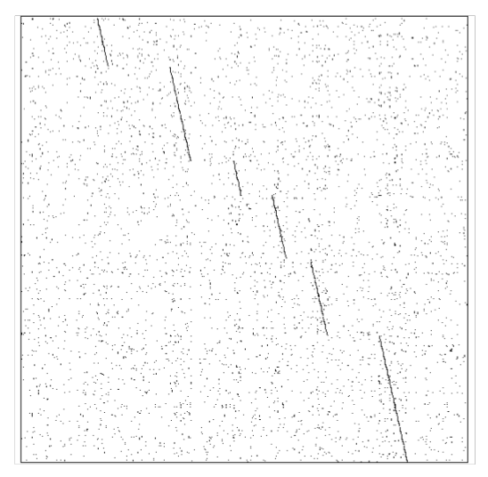

1. Given the DNA sequence S= 5’-GAATTC-3’, how does the dotplot between S and its complementary, cS, look like?

**Part II (one question, 10 points)**

In one of the strands of a double stranded DNA molecule there is 30 % of Adenine ([A]=30%) and 24 % of guanine ([G] = 24%). Calculate the following, if possible (if impossible, write “I”):

1. [A]+[G] :
2. [T] :
3. [C] :
4. [T]+[C] :
5. [A] on the other strand :
6. [T] on the other strand :
7. [A]+[T] on the other strand :
8. [G] on the other strand :
9. [C] on the other strand :
10. [G]+[C] on the other strand :

**Part III (two questions, 10 points each: total 20)**

Below is the double-stranded DNA sequence of part of a hypothetical bacterial genome, which happens to contain a very small gene.

5’ – TATAAATTATGTCTGCTATAAAATAACCCGGT– 3’

||||||||||||||||||||||||||||||||

3’ – ATATTTAATACAGACGATATTTTATTGGGCCA– 5’

1. What is the sequence of gene and of the longest protein that can be produced by this DNA sequence? Label the N and C termini.
2. Propose a single base pair **deletion** that will lead to the mutated sequence still coding for a protein, albeit smaller, with the same START codon. ***Note that you still need a STOP codon in phase with the START codon***. Give the sequence of the shorter protein. Label the N and C termini.

**Part III: (one question, 10 points)**

We want to find the best alignment(s) between the protein sequences FAFWC and FWFC. The scoring scheme S is defined as follows: S(i,i) = P, and S(i,j) = M otherwise. There is a constant gap penalty of G (gaps at the beginning are considered). The dynamic programming matrix is shown below. What were the values of P, M, and G? Write the best alignment found using those values.

|  |  |  |  |  |  |
| --- | --- | --- | --- | --- | --- |
|  | F | A | F | W | C |
| F | 5 | -4 | 3 | -4 | -4 |
| W | -4 | 3 | 1 | 8 | 1 |
| F | 3 | 1 | 8 | -1 | 6 |
| C | -4 | 1 | -1 | 6 | 11 |

**Appendix:**

**Appendix A: Genetic Code**

|  |  |  |  |  |  |
| --- | --- | --- | --- | --- | --- |
|  | U | C | A | G |  |
| U | Phe  Phe  Leu  Leu | Ser  Ser  Ser  Ser | Tyr  Tyr  STOP  STOP | Cys  Cys  STOP  Trp | U  C  A  G |
| C | Leu  Leu  Leu  Leu | Pro  Pro  Pro  Pro | His  His Gln  Gln | Arg  Arg  Arg  Arg | U  C  A  G |
| A | Ile  Ile  Ile Met/Start | Thr  Thr  Thr  Thr | Asn  Asn  Lys  Lys | Ser  Ser  Arg  Arg | U  C  A  G |
| G | Val  Val  Val  Val | Ala  Ala  Ala  Ala | Asp  Asp  Glu  Glu | Gly  Gly  Gly  Gly | U  C  A  G |